Follow the below link document steps to download and import Acadgild Spark VM in
the Oracle Virtual Box.

https://drive.google.com/file/d/0ByJLBTmJojjzQ2hLc1RLX3pST0U/view
Steps to import acadgild vm:
1.Open the virtual box and then follow the below steps:
Click on File --→ Import Appliance.
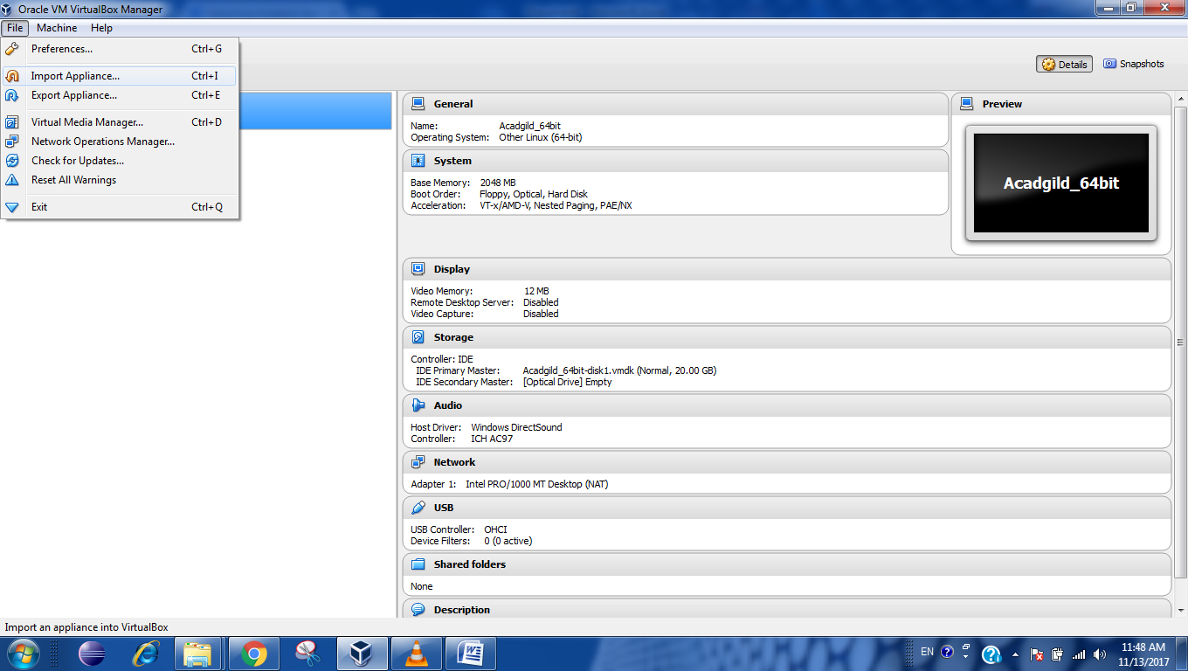

2. Click on the Folder option as shown in the below screenshot
to browse to the location where hadoop vm is present.
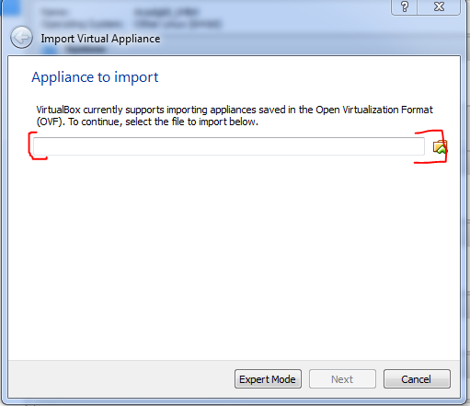
Select the VM to be imported an then click on Open
button.
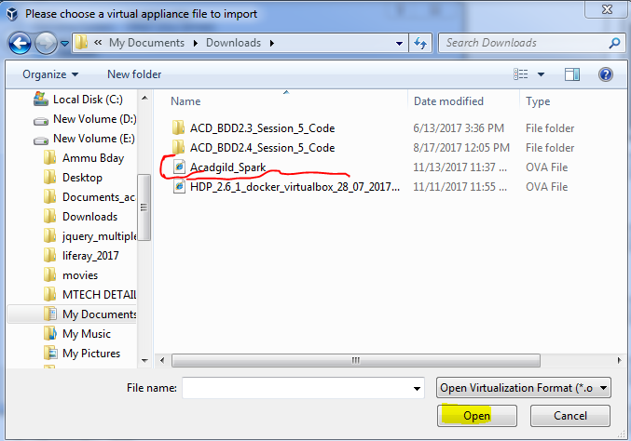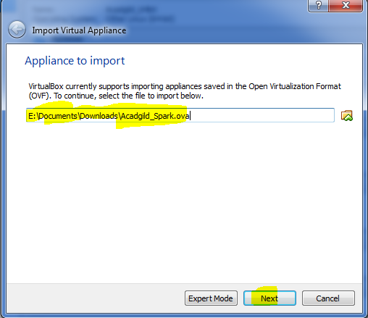
5. Click on import button to start importing the acadgild
VM.
6. Once the vm starts getting imported it gives a prompt
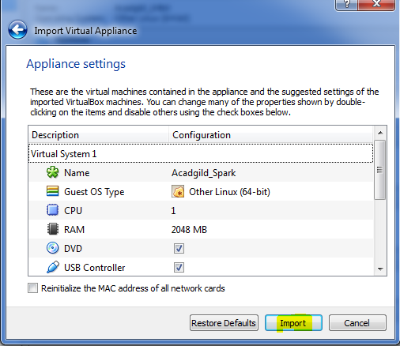
as shown below:
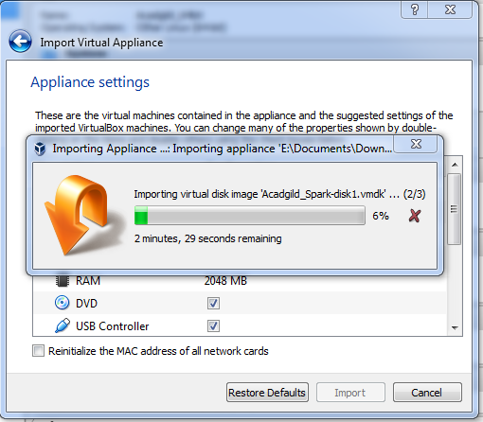
Once the importing gets finished, we need to click
on the start button
8. We need to give the password as acadgild.
Password: acadgild
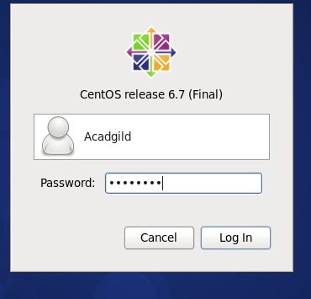
9. Open the terminal and type the command jps to
check the list of daemons, we need to start all the
daemons for the first time.
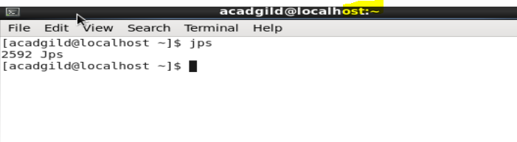Starting Hadoop daemons

1. Starting NameNode, DataNode, ResourceManager, NodeManager and
Jobhistoryserver

NOTE: Change the directory to sbin of hadoop before starting the daemon.
In the VM hadoop-2.6.0 is present in /user/local directory
Command: $ cd hadoop-2.6.0
$ cd sbin
Starting namenode:
Command: ./hadoop-daemon.sh start namenode
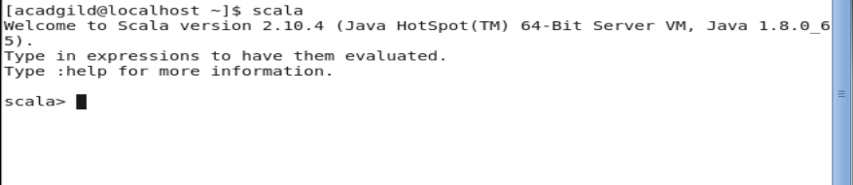
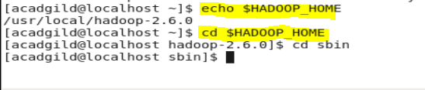
Starting datanode:
Command: ./hadoop-daemon.sh start datanode
Starting resourcemanager:
Command: ./yarn-daemon.sh start resourcemanager
Starting nodemanager:
Command: ./yarn-daemon.sh start resourcemanager
Type the command jps to check the health of the
daemons, if all the daemons will be running then cluster
is ready.
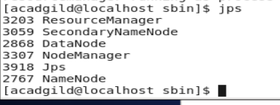
To Stop all the Running daemons type the command ./stop-all.sh
11.Starting Spark daemons Master,Workers
Move into the sbin folder of spark installed directory(Here spark is installed in
/usr/local/spark/ directory.)

Starting Master:
Command: ./ start-master.sh

Starting Slaves:
Command: ./start-slaves.sh

Now you can type the jps command to check the Master and Slave daemons
running.

Working on Eclipse in Acadgild VM:
To Open Eclipse, Double click on the Link to eclipse icon on the Desktop.


Assignment12.2

Given a list of strings - List[String] (“alpha”, “gamma”, “omega”, “zeta”, “beta”)
First open the scala terminal,abd create a list of string in that as:
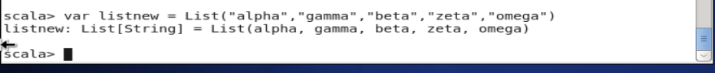
- find count of all strings with length 4
For this we will give the code in the scala terminal and will get the count of fields with string length ===4
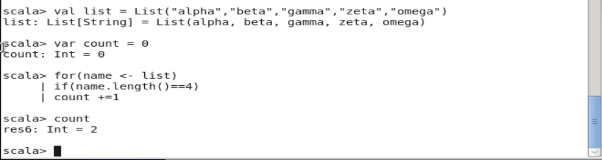
- convert the list of string to a list of integers, where each string is mapped to its
corresponding length

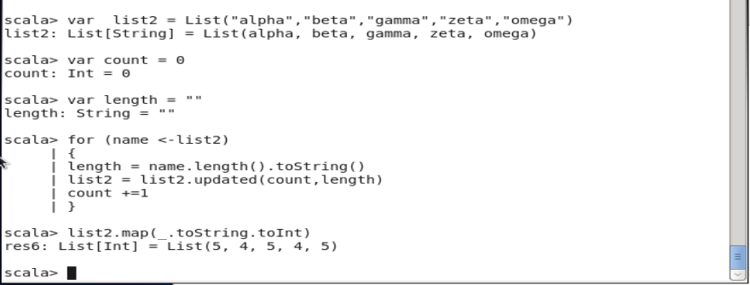
- find count of all strings which contain alphabet ‘m’
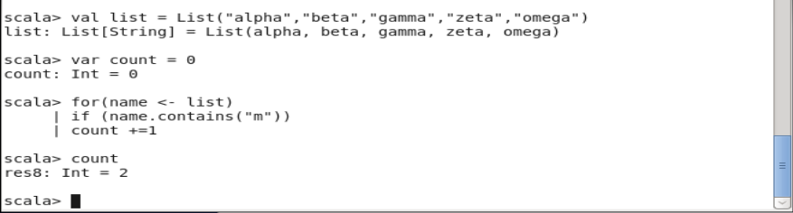
- find the count of all strings which start with the alphabet ‘a’

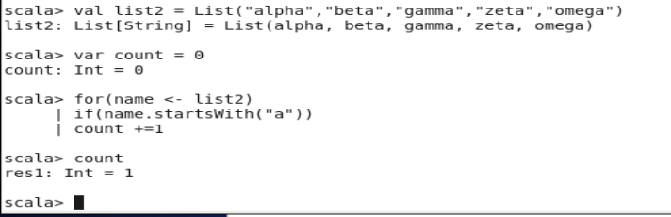

Create a list of tuples, where the 1st element of the tuple is an int and the second
element is a string.
Example - ((1, ‘alpha’), (2, ‘beta’), (3, ‘gamma’), (4, ‘zeta’), (5, ‘omega’))
- for the above list, print the numbers where the corresponding string length is 4 fot list of tuple
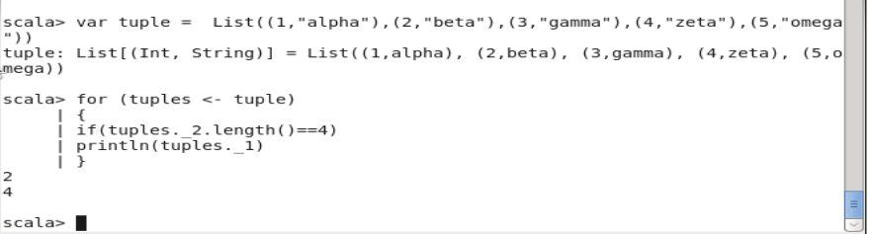

- find the average of all numbers, where the corresponding string contains alphabet ‘m’
or alphabet ‘z’
